

DEVOPS FOR CLOUD COMPUTING
Assignment

Name:
Tehreem Mirza

Registeration No:
FA22-BSE-088

Section:
BSE-8B

Submitted To:
Sir Muhammad Ibrahim

Task: Jenkins installation and git hub connection to it and creating a first job.
JDK 21 Download:
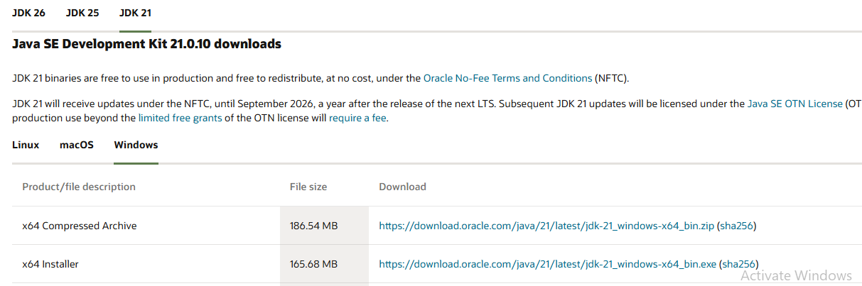

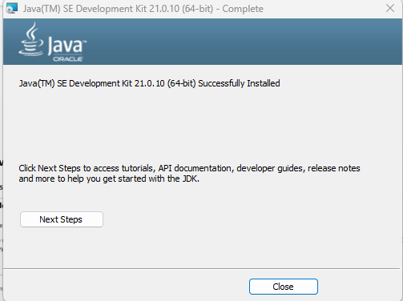

Created a new variable in environmental variables
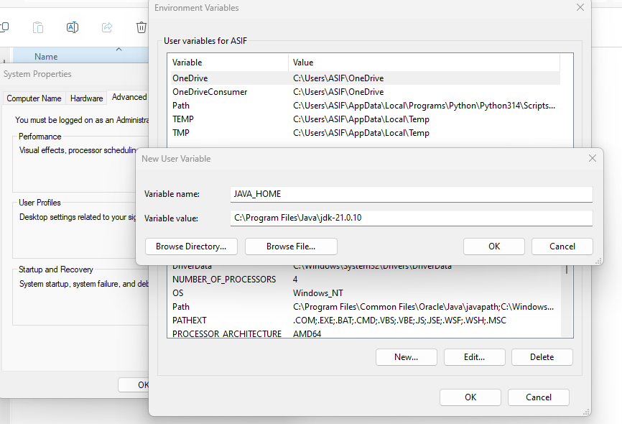
Java JDK installation is completed.
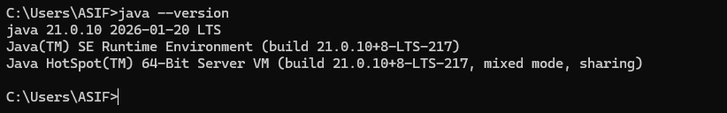

Installing Jenkins on windows
Open website and downloading windows one
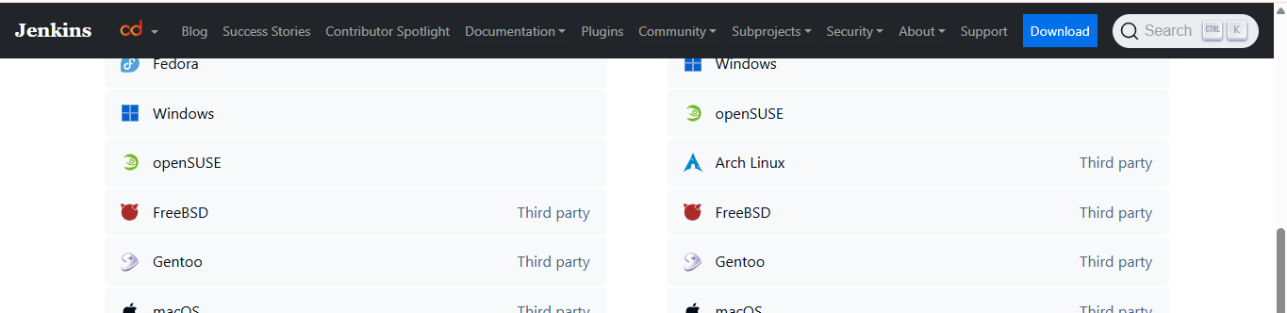

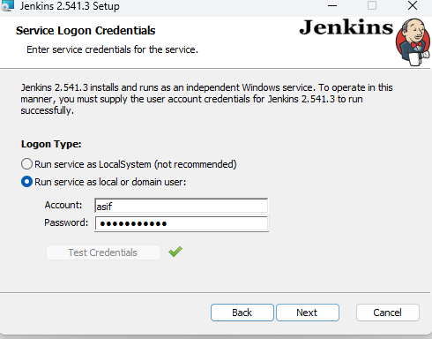

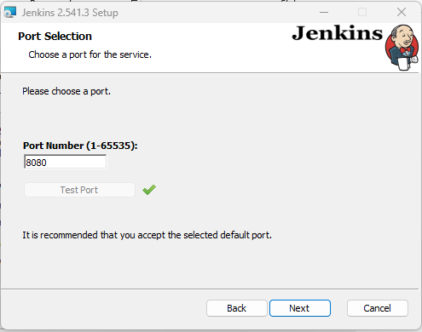

Jenkins installation completed
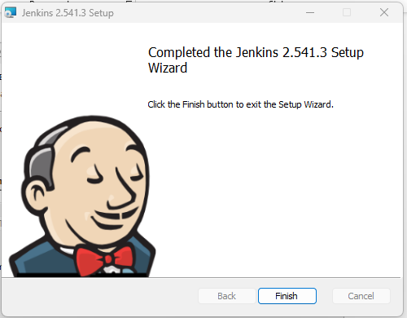

Now open localhost:8080
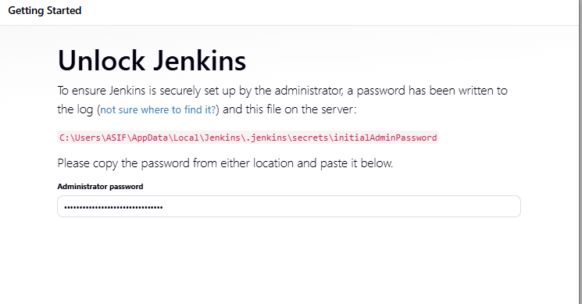

Installation of plugins
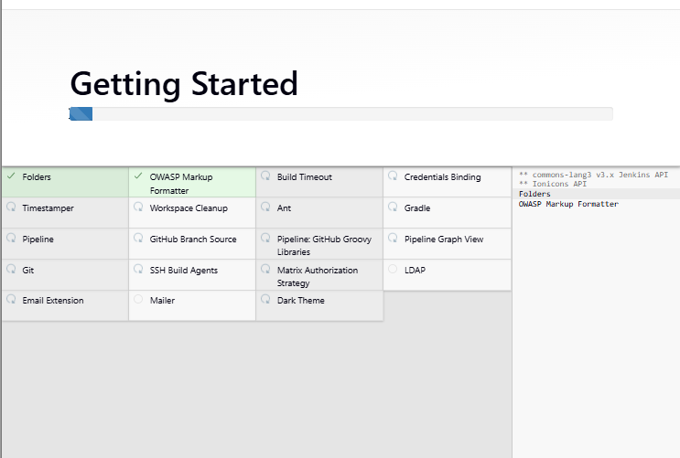
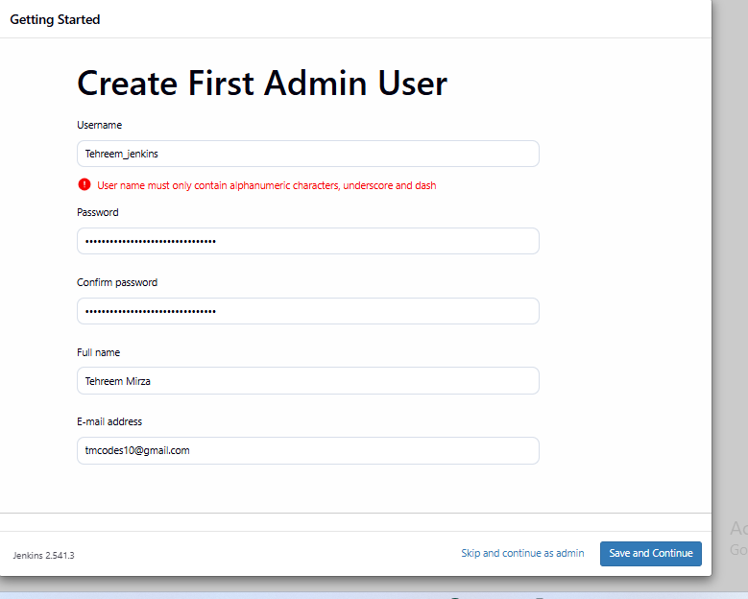

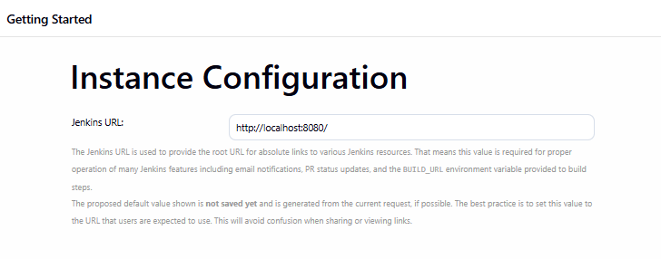

Jenkins is now installed and completed
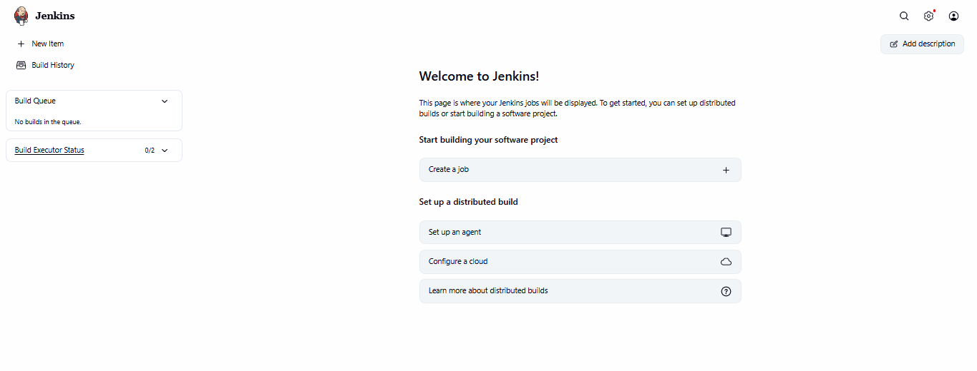

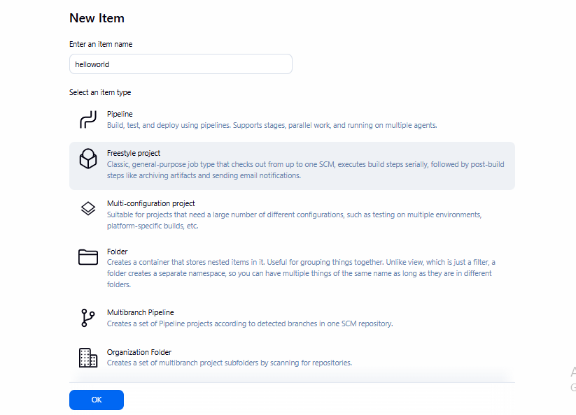

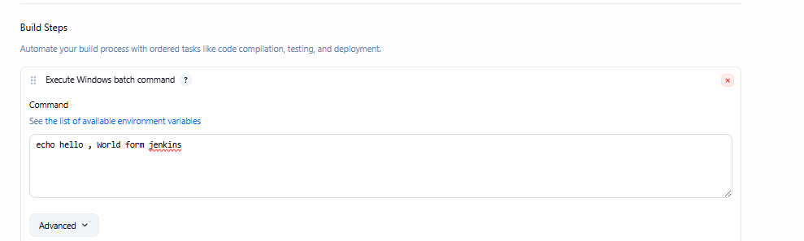

Simple hello world program run
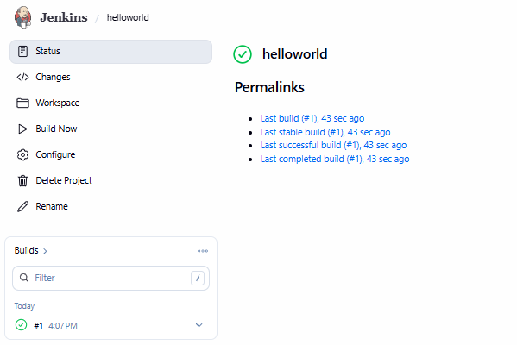

GitHub connection
Creating repository on github
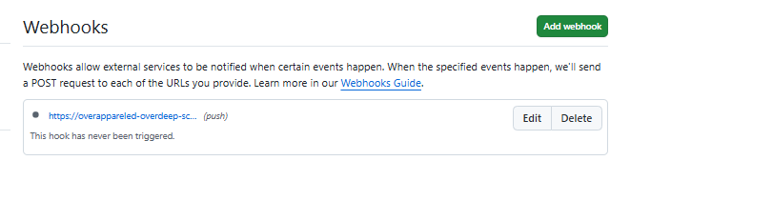
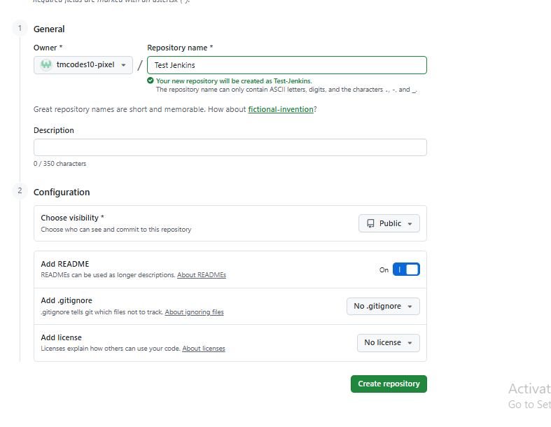

Adding ngrok link to webhook

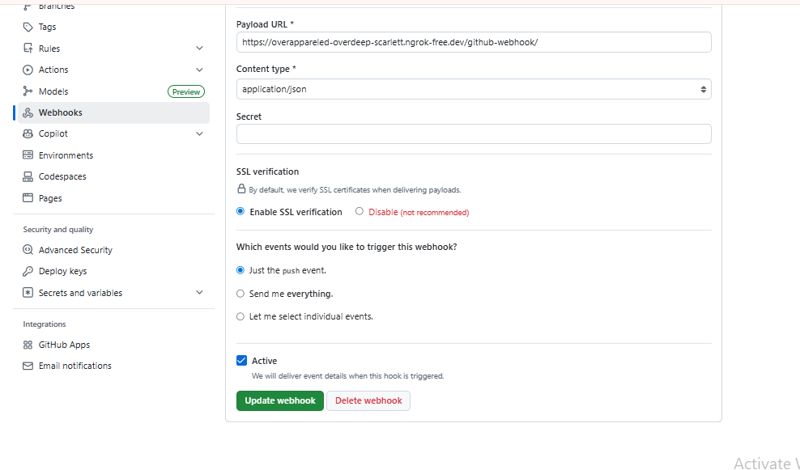

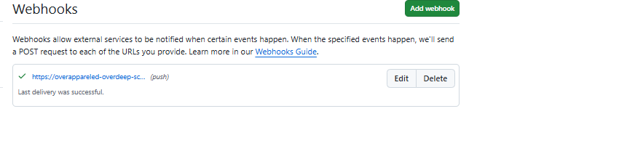

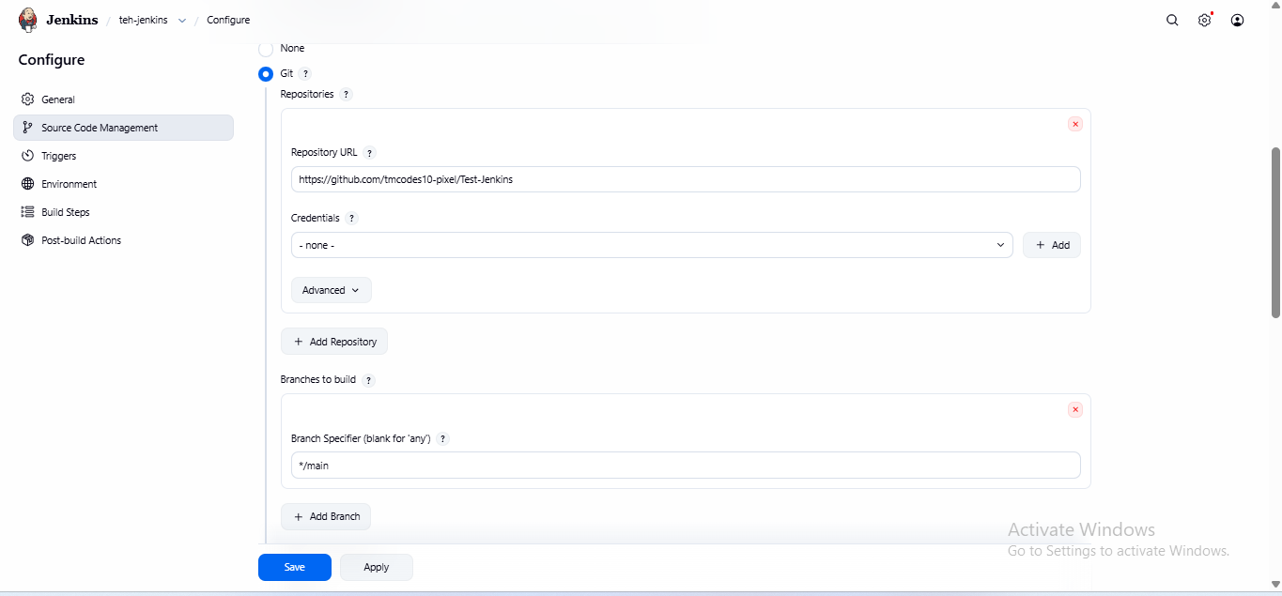

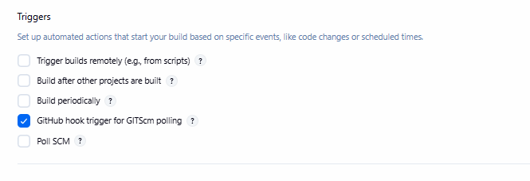

Task 1: Jenkins Installation on EC2 Machine
Creating an instance on AWS
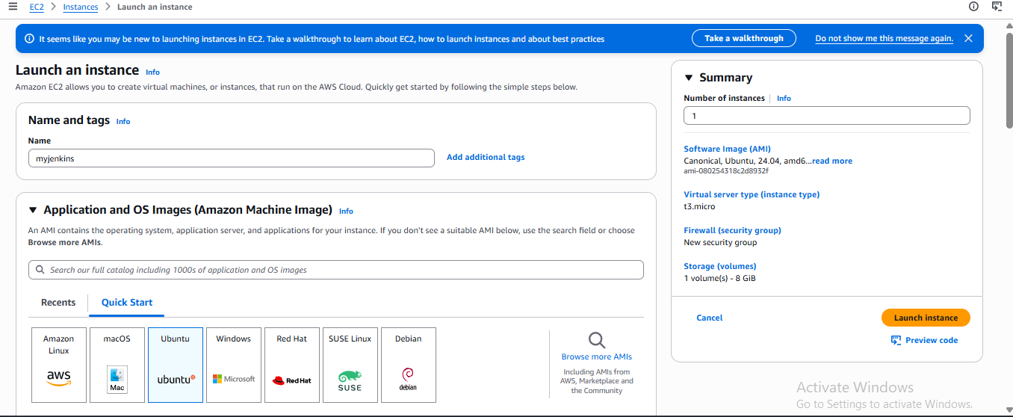
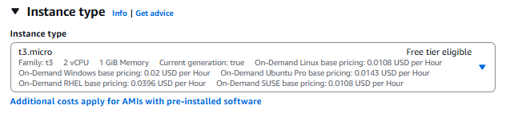
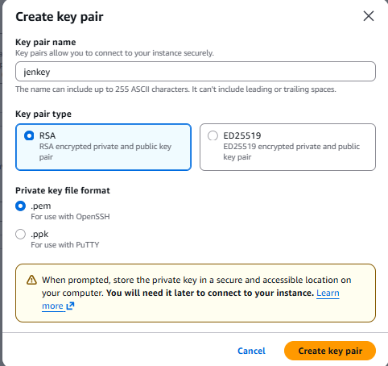

Instance has been created

Accessing AWS on ubuntu machine
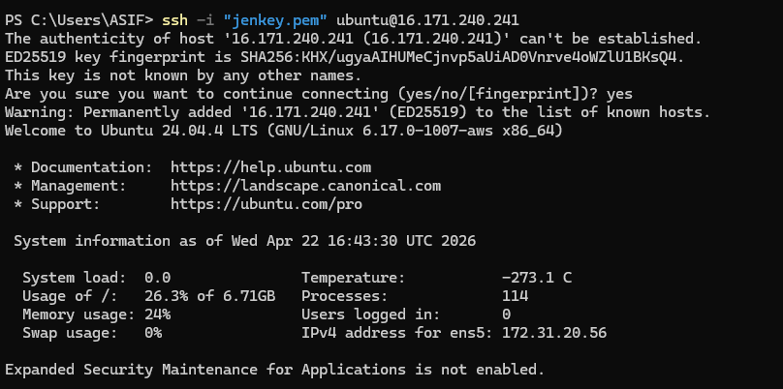

Installing package jdkopen-21
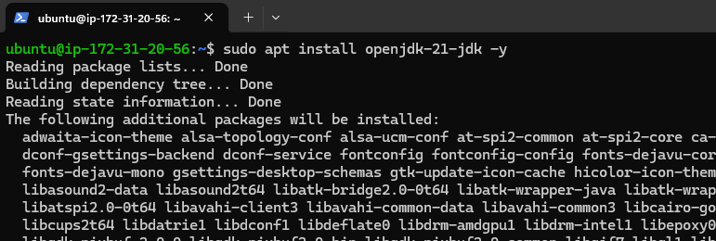
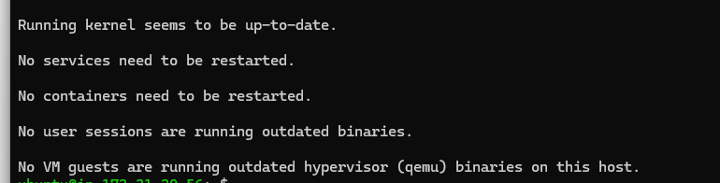
Installed jdk on wsl ubuntu
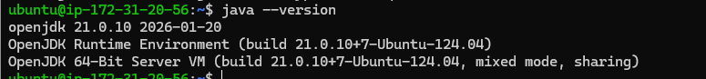

Installing Jenkins
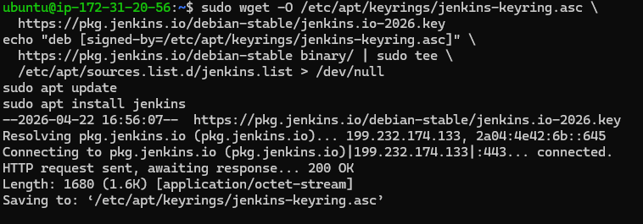
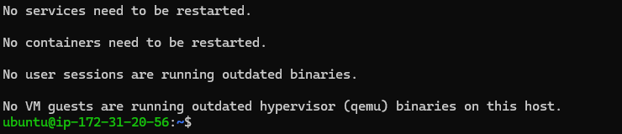

Enabling system Jenkins service on wsl

Jenkins start and status check to verify
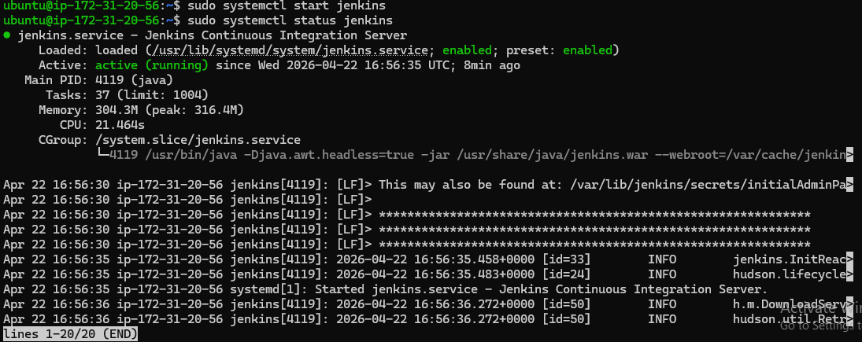

Adding a rule in edit bounds to allow port to access Jenkins
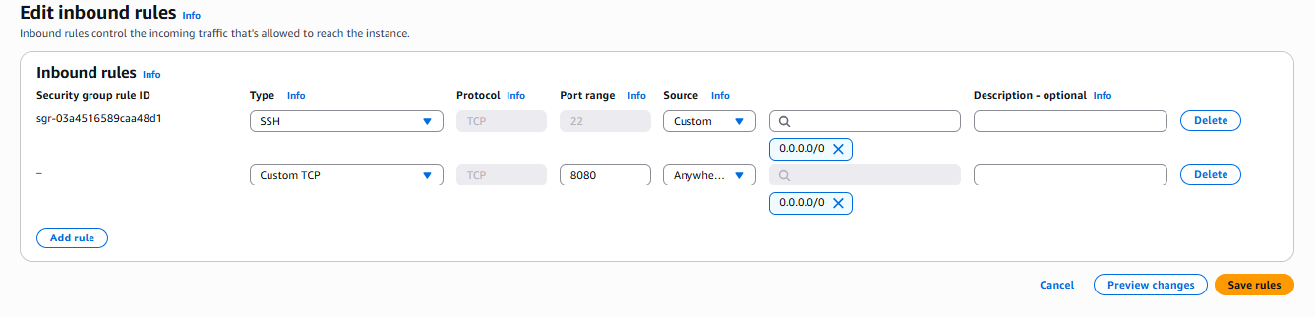

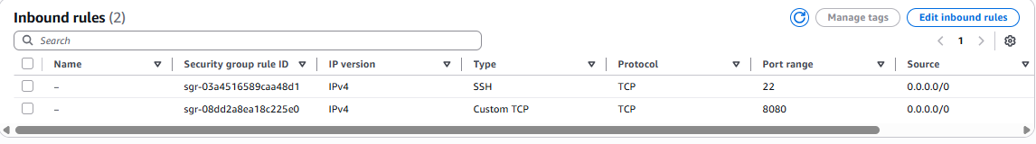

Jekins’s login
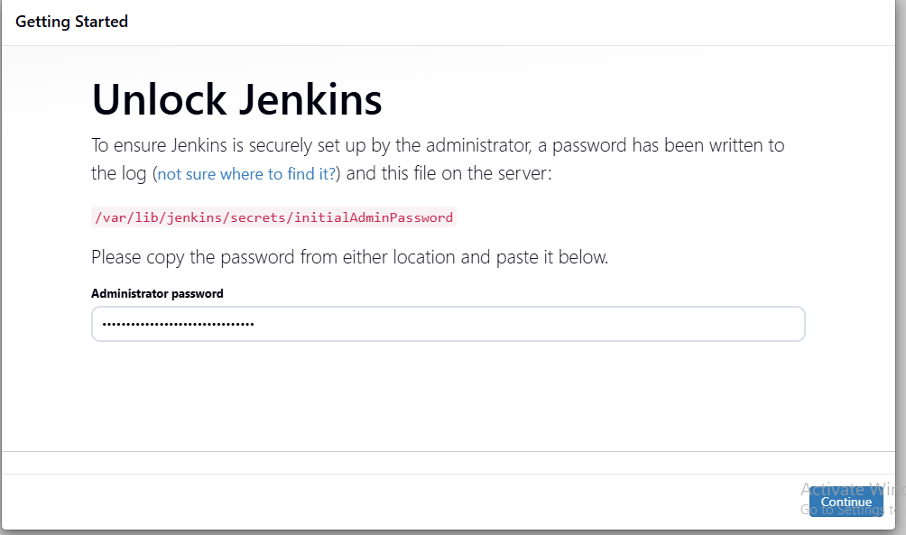

Plugins install
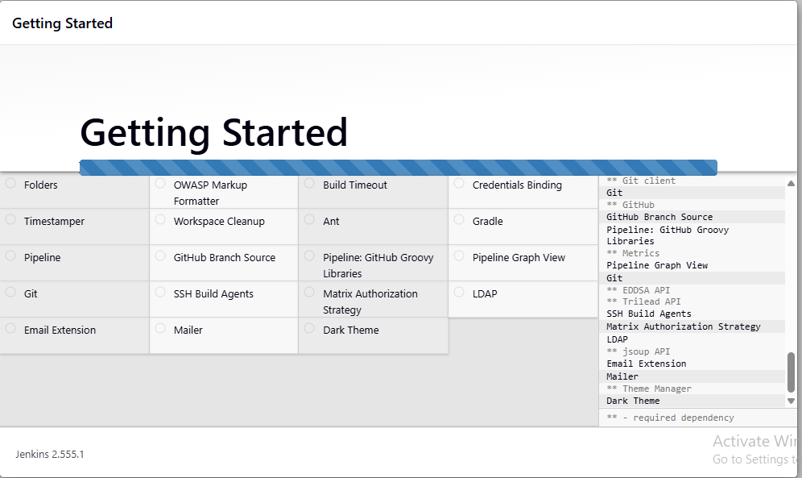
Creating a user
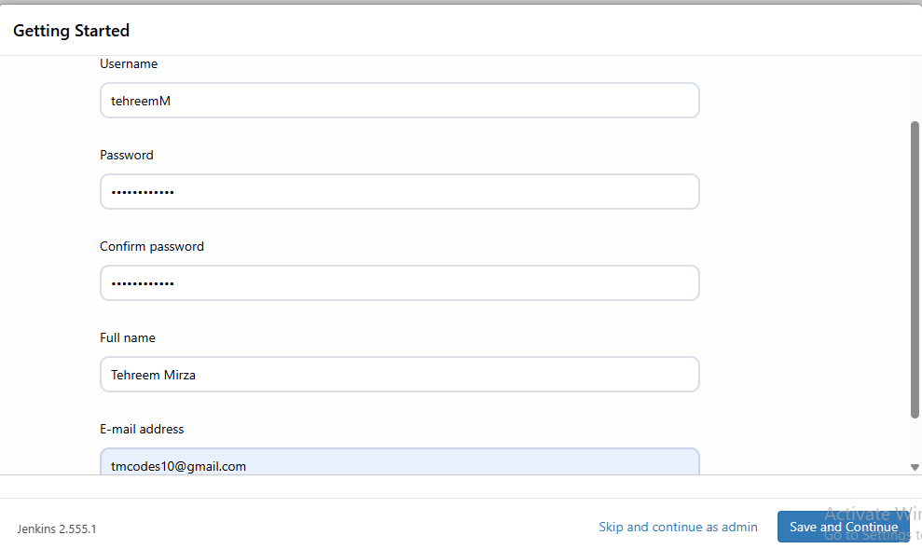
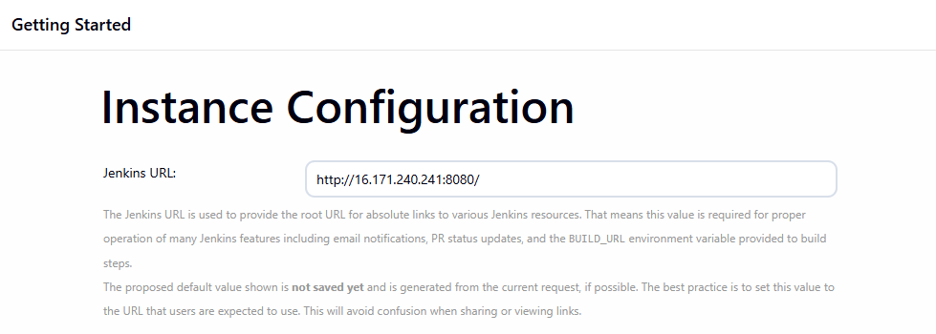

Task 2: Complete CI/CD pipeline creation on AWS cloud for 3 tier Mern stack application
Creating an instance
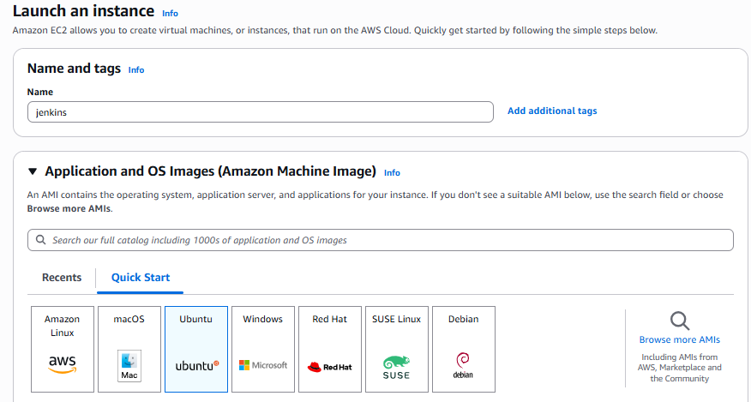
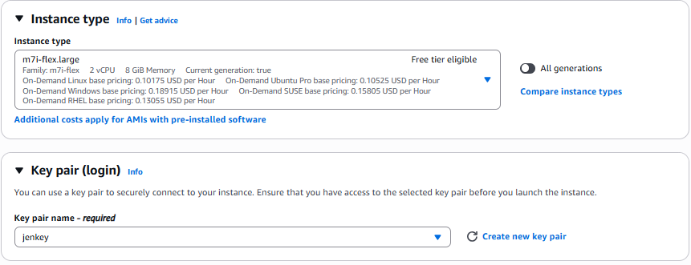
Instance has been created

Allowing port so adding a rule in edit bound
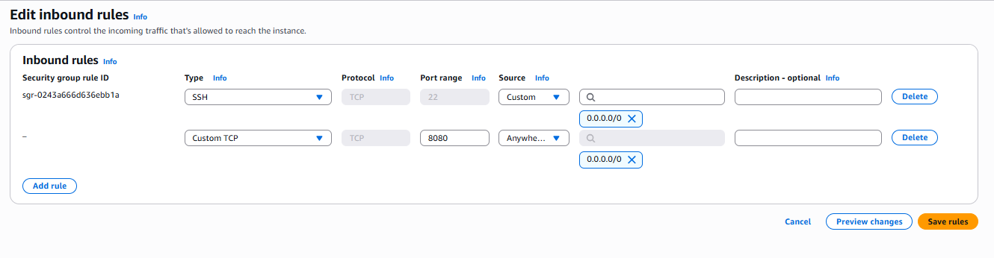
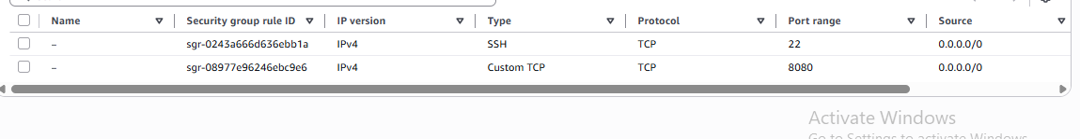
Login into EC2 machine


